Dashbaord implementation using Fabric-Items:

1.DataFlow Gen2:
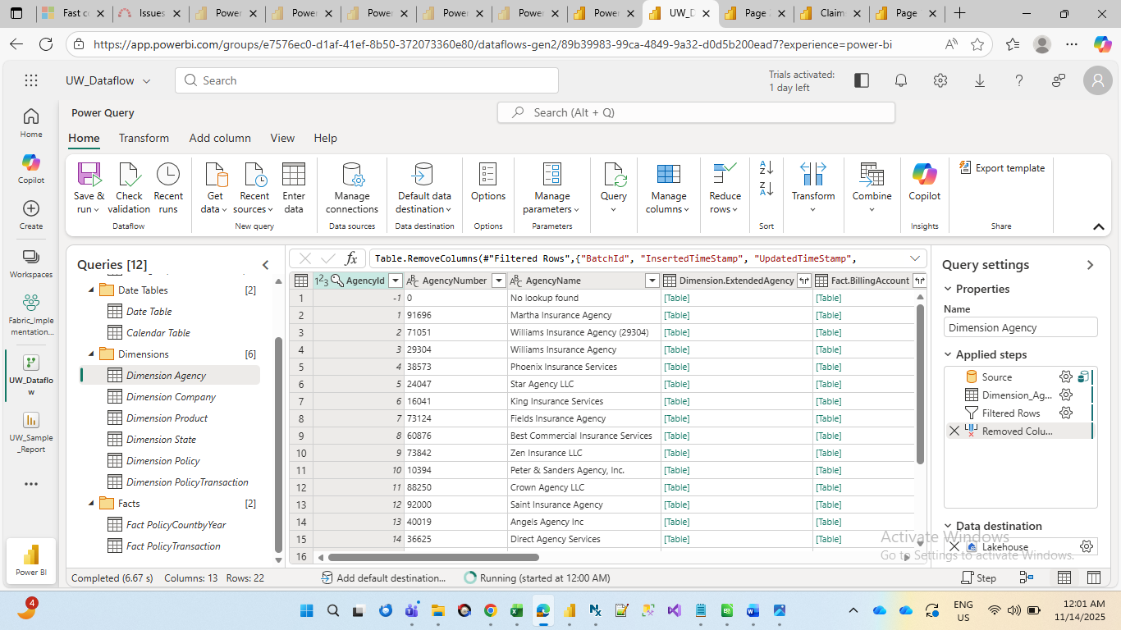

2.Created Lakehouse (destination for Dataflow tables):
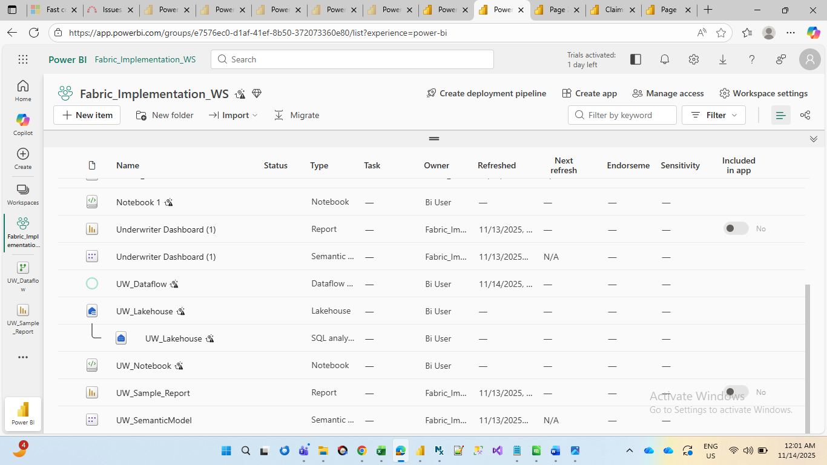
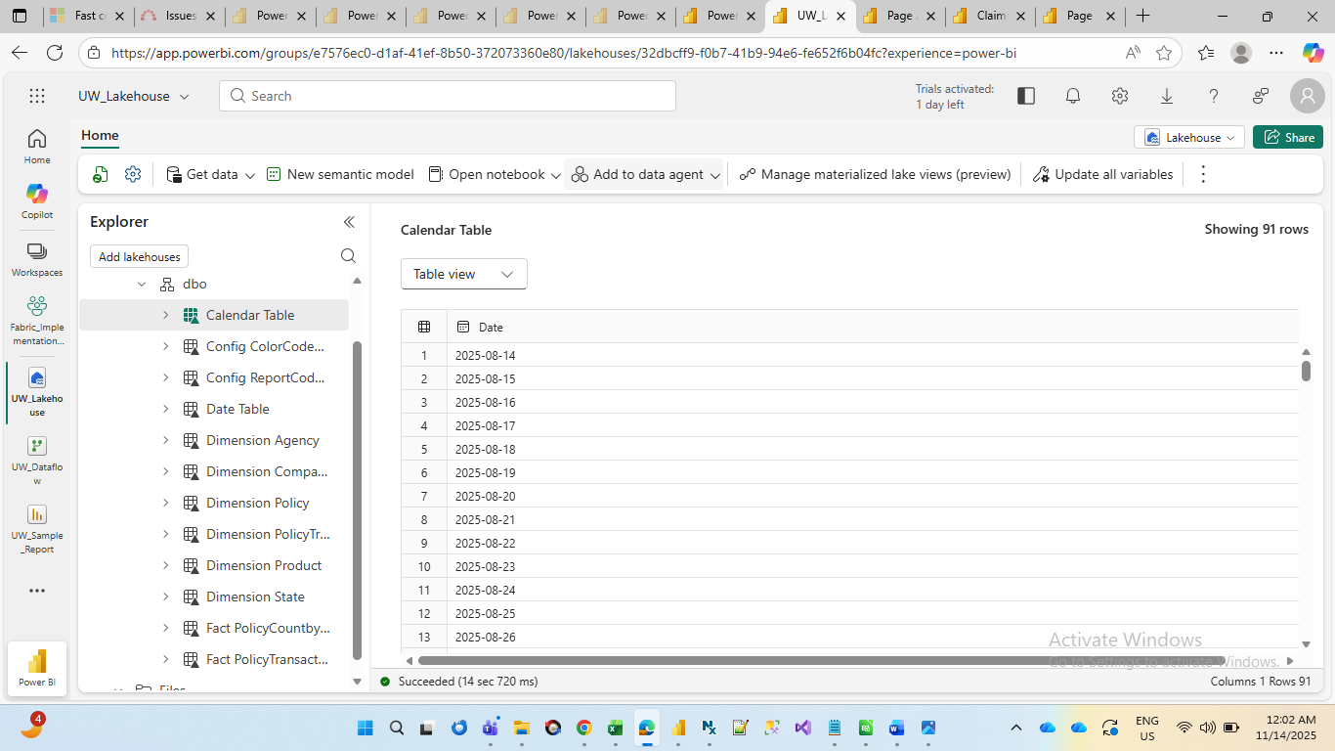

3.1 Querying tables in lakehouse:
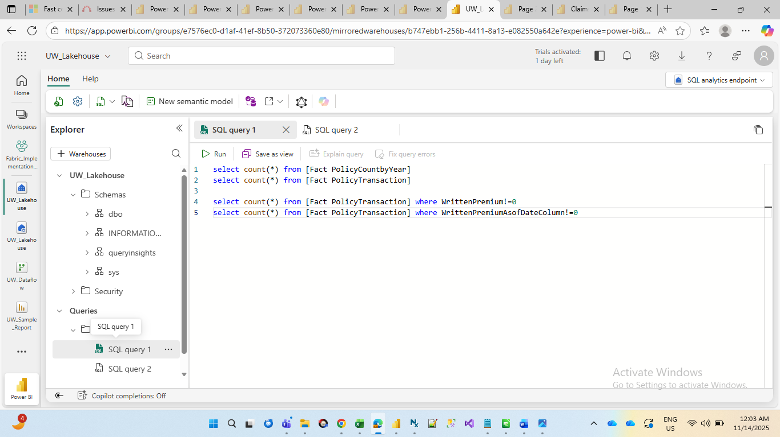

4.Semantic Model (DirectLake mode):
Built a Semantic Model using Lakehouse tables, establishing relationships and creating DAX measures for reporting.
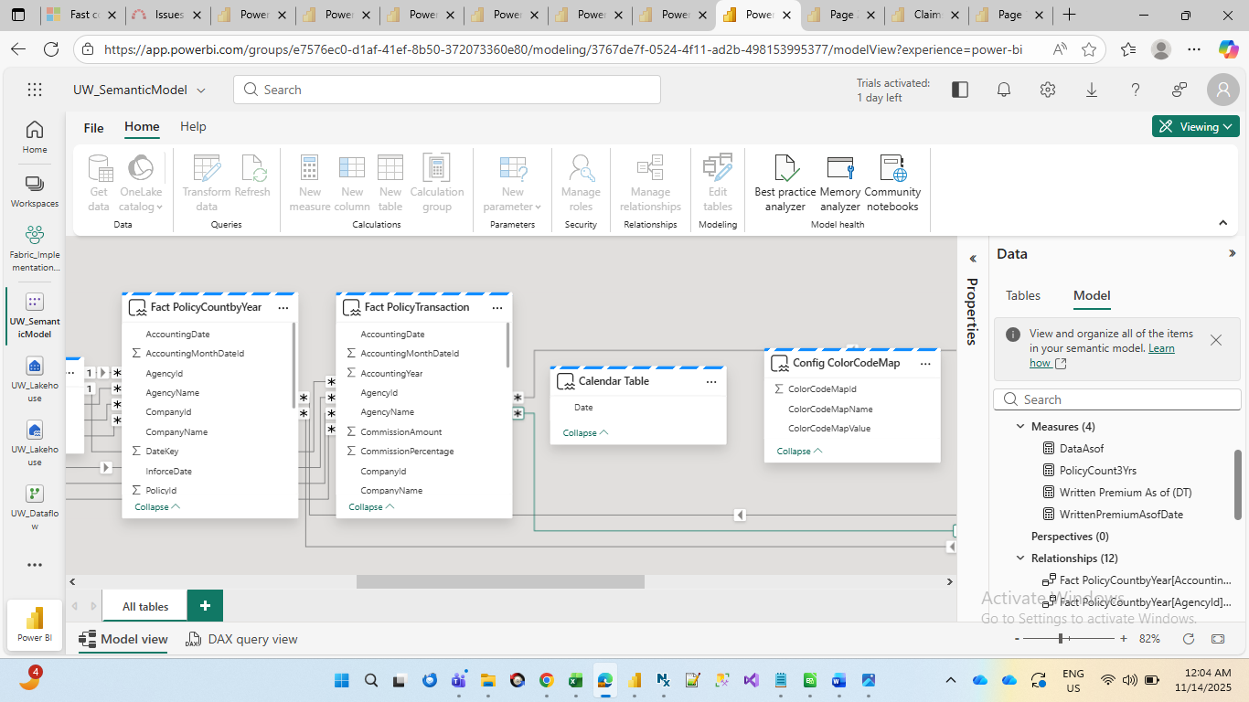

5.Power-BI-Underwriter-Dashboard-using-Microsoft-Fabric flow:
